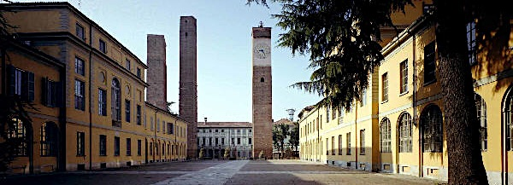

Dottorato in Genetica, Biologia Molecolare e Cellulare
Scuola di Dottorato in Scienze della Vita “Camillo Golgi” - Università degli Studi di Pavia
Course of Molecular Basis of cellular processes

"DNA and RNA metabolisms meet at chromatin to control genome stability"

Organizers: Dr. Giuseppe Biamonti, Dr. Claudia Ghigna, Dr. Giordano Liberi and Dr. Alessandra Montecucco, Istituto di Genetica Molecolare, CNR, Pavia.

11-15 Aprile 2016

Synopsis. The objective of this course is to provide a comprehensive view of the complex network of interactions that contribute to the maintenance of genome stability in eukaryotes through modulation of the chromatin structure. Seminars will be focused on the emerging crosstalk between non-coding RNAs, chromatin and transcription/pre-mRNA splicing in the context of DNA damage. The role of epigenetic programs, acting via chromatin organization, in the definition of cell- and tissue-specific programs and their contribution to human diseases will be also discussed.

Monday 11th April, 2016
14:30 – 16:00
Prof. MARCO MUZI-FALCONI
Università degli Studi di Milano, Milan
Title: “The importance of being DNA: rNTP incorporation during DNA synthesis and RNase H modulate genome stability”

-----------------------------

Tuesday 12th April, 2016
14:30 – 16:00
Prof. MARCO E. BIANCHI
San Raffaele University and San Raffaele Scientific Institute, Milan
Title: “Control of histone expression and nucleosome number”

16:15 -17:45
Dr. RAFFAELLA DI MICCO
San Raffaele Telethon Institute for Gene Therapy (TIGET), Milan
Title: “Epigenetic and transcriptional regulation of cell identity”

-----------------------------

Wednesday 13th April, 2016
14:30 – 16:00
Dr. CHIARA LANZUOLO
Institute of Cell Biology and Neurobiology IBCN-CNR, Rome and Istituto Nazionale di Genetica Molecolare "Romeo ed Enrica Invernizzi”, Milan
Title: “Nuclear architecture in muscle differentiation”

16:15 -17:45
Dr. DAVIDE GABELLINI
Scientific Institute and San Raffaele Scientific Institute, Milan
Title: “Epigenetic regulation in muscular dystrophy and obesity”

-----------------------------

Thuesday 14th April, 2016:
14:30 – 16:00
Dr. EMANUELE BURATTI
International Centre for Genetic Engineering and Biotechnology (ICGEB), Trieste
Title: “Role of pre-mRNA splicing in human health and disease”

16:15 -17:45
Prof. SILVIA BARABINO
Università degli Studi di Milano-Bicocca, Milan
Title: “The R-loop connection: altered genome integrity in ALS”

-----------------------------

Friday 15th April, 2016
14:30 – 16:00
Dr. FRANCESCO NICASSIO
Istituto Italiano di Tecnologia, Milan
Title: “Functions and regulation of microRNA in development and disease”

16:15 -17:45
Dr. SOFIA FRANCIA
IFOM - The FIRC Institute of Molecular Oncology Foundation, Milan and Institute of Molecular Genetics National Research Council (IGM-CNR), Pavia
Title: “DNA damage induced RNA (DDRNAs): local activators of the DNA damage signalling”

