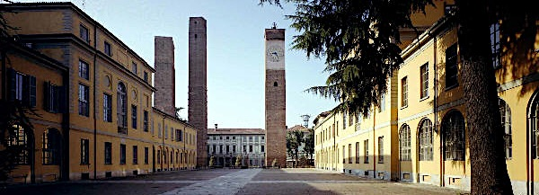

Dottorato in Genetica, Biologia Molecolare e Cellulare
Scuola di Dottorato in Scienze della Vita “Camillo Golgi” - Università degli Studi di Pavia

Esami del corso
Molecular microbiology and virology
“ Emerging and re-emerging pathogens: control strategies and drug-resistance”
Docenti responsabili: A. Albertini, C. Calvio, G. Maga, R. Migliavacca, L. Pagani, M.R. Pasca, D. Sassera

29 Maggio 2015

Aula Buzzati-Traverso, edificio di Genetica e Microbiologia,
Dip. di Biologia e Biotecnologie, Univ. di Pavia

Gozzo Francesco (14:00-14:20)
"Rapid Evolution of Culture-Impaired Bacteria during Adaptation to Biofilm Growth."
Jon Penterman et al. Cell Reports. 2014;6(293-300)

Cremaschi Paolo (14:20-14:40)
"Molecular characterization of host-specific biofilm formation in a vertebrate gut symbiont."
Steven A. Frese et al. PLoS Genet. 2013;9(12)

